Part 1: Embodied Noticing
Solitude Tailings Storage Facility — Globe, Arizona
CIVE 438 · Fundamentals of Environmental Engineering · Spring 2026
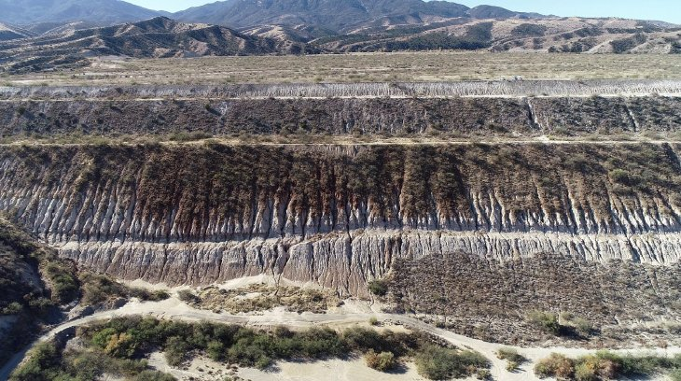
Figure 1. Aerial view of the earthen containment dam at the Solitude Tailings Storage Facility, Globe, Arizona. Photograph provided by BHP.
This picture is taken from Solitude Tailings Storage Facility in Globe, Arizona. This is the site of my senior design project, as well as the inspiration for this tool.
Direct Observation 1
The face of the earthen dam exhibits parallel erosion channels carved into the slope surface. The channels are densely spaced across the full visible height of the dam face, with exposed grey-white material visible between oxidized surface zones. The channels appear to be on the order of tens of centimeters deep.
Direct Observation 2
The crest of the dam is flat and wide, with sparse, low desert shrub vegetation. The toe of the dam meets an unvegetated, sandy alluvial flat with a dirt access road. The surrounding terrain is semi-arid high desert, with dry brown hillsides and no visible surface water in the foreground.
Inference 1
The dense pattern on the dam face indicates active surface erosion driven by precipitation runoff. The erosion appears to be ongoing and unchecked, as the absence of any vegetation, riprap, or erosion control matting on the slope suggests either that no surface protection was installed or that it has been lost. In a semi-arid climate like Globe, Arizona, even low annual precipitation can produce high-intensity convective storms capable of rapid crack formation on unprotected fine-grained slopes.
Inference 2
The rust-brown discoloration concentrated along the upper dam face and at the top of the rills is likely the product of iron sulfide oxidation, possibly caused by acid rock drainage. Where tailings or sulfide-bearing fill material is exposed at the surface and contacted by oxygen and water, pyrite and other iron sulfides oxidize to produce ferric hydroxide precipitates and sulfuric acid. The spatial pattern is consistent with a shallow oxidation front progressing downward from the surface.
Explicit Unknown
It is not possible to determine from this photograph whether the cracks have reached the interior tailings mass or is confined to a surface cover or compacted fill layer. The depth of the erosion channels relative to the total dam cross-section is unknown. If erosion has only penetrated a surficial soil layer, remediation may be straightforward. If channels have exposed or are approaching the tailings themselves, contaminant mobilization via surface runoff becomes a direct and immediate concern. Core borings or LiDAR-derived volume estimates would be needed to answer this.
Engineering Question
What annual percolation rate through a redesigned single-layer cover would be required to prevent acid rock drainage from reaching groundwater at this site, and can a compacted soil cover meeting that target be constructed using locally available materials?

